**LEBANESE AMERICAN UNIVERSITY**

**USAID – HIGHER EDUCATION SCHOLARSHIP PROGRAM**

**HES - Volunteering Program Verification Form**

This form is to be used to document volunteering hours. If a student volunteers for multiple organizations, a separate form must be used for each organization. **This form must be turned in by the 28th of each month, the latest.**

I certify that the scholar Malak Amer completed a total of 5 hours of service at InnovaThrive.

The hours were completed hours as per the below:

Hours # 0 (date) _2/12 – 6/12_ (initials of supervisor) __A.K.___

Hours # 0 (date) _9/12 – 13/12_ (initials of supervisor) __A.K.___

Hours # 0 date) _16/12 – 20/12 (initials of supervisor) __A.K.___

Hours # 5 date) _23/12 - 27/12 (initials of supervisor) __A.K.___

Brief description of the activities the scholar performed or participated in:

Malak did a research that covers AI's role in education through adaptive platforms and assessments, its applications like career guidance, benefits like engagement, challenges like access, and future directions such as hybrid models and multi-language support.

Written feedback about the scholar’s performance:

Malak showcased excellent research and organizational skills in analyzing AI’s role in education. Her ability to connect theoretical insights with practical applications highlights her adaptability and forward-thinking approach.

Please rate the overall performance of the scholar at your organization:

|  |  |  |  |
| --- | --- | --- | --- |
|  | Mastery (5) | Proficient (3) | Emerging (1) |
| **Problem solver** | X |  |  |
| **Engaged & Committed** | X |  |  |
| **Open-minded & multicultural** | X |  |  |

Signature

& stamp

__________________________

_

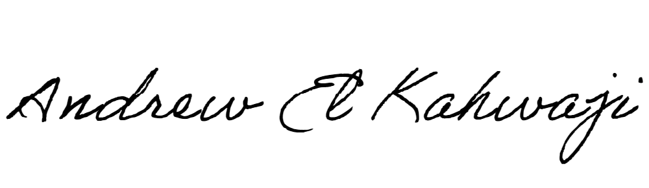

Printed Name _Andrew El Kahwaji_

Date __26/12/2024___

Email __andrew.lifesculptor.coo@gmail.com __

Phone __+961 71 914 378__